1.Komputer Grafik 2

import java.awt.Graphics;
public class line2 extends java.applet.Applet {
public void paint (Graphics g) {
g.drawLine (100,100,200,200);
g.drawString ("KOMPUTER Graphics, DOSEN : NAHOT FRASETIAN, M.KOM",50,90);
}
}
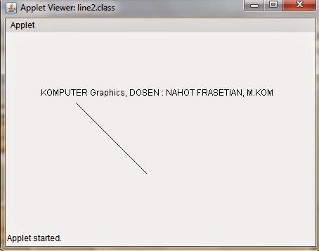

1.1. Versi saya
import java.awt.Graphics;

public class heniLine extends java.applet.Applet {
public void paint (Graphics g) {
g.drawLine (200,150,200,250);
g.drawString ("KOMPUTER Graphics, DOSEN : NAHOT FRASETIAN, M.KOM",50,90);
g.drawString ("Nama : Heni Meilani, NPM : 201143500292 ",80,110);
}
}
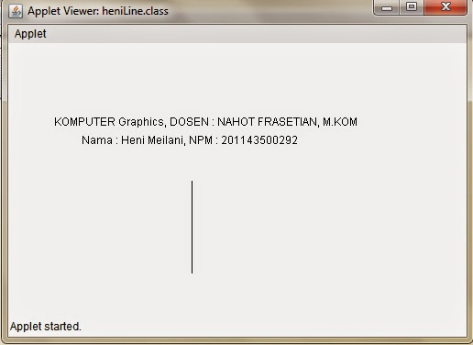

2. Komputer grafik 3

import java.awt.Graphics;
public class MyLine1 extends java.applet.Applet {
public void paint (Graphics g) {
g.drawRect (50,100,150,250);

}
}
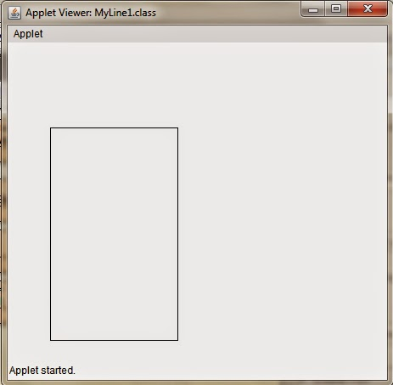

2.1. Versi saya
import java.awt.Graphics;

public class heniMyLine1 extends java.applet.Applet {
public void paint (Graphics g) {
g.drawRect (50,100,350,150);

}
}
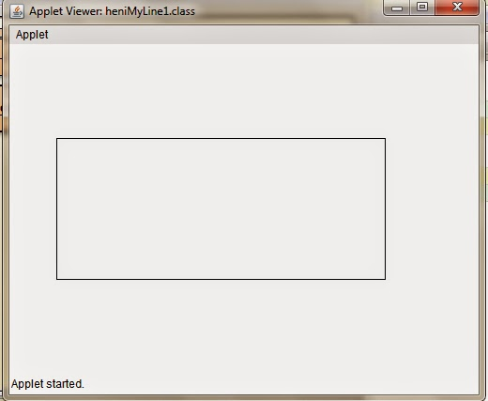

3.Komputer Grafik 4

import java.awt.Graphics;
public class MyLine extends java.applet.Applet {
public void paint (Graphics g){
g.drawString ("KOMPUTER Graphics, DOSEN : NAHOT FRASTIAN, M.KOM",50,90);
g.drawRect (50,100,150,250);
}
}
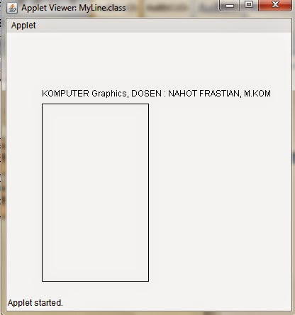
3.1Versi saya
import java.awt.Graphics;
public class heniMyLine extends java.applet.Applet {
public void paint (Graphics g) {

g.drawString ("KOMPUTER Graphics, DOSEN : NAHOT FRASTIAN, M.KOM",60,90);
g.drawString ("Nama : Heni Meilani, NPM : 201143500292",90,110);
g.drawRect (50,50,350,100);
}
}
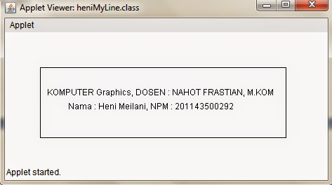

4.Komputer Grafik 5

import java.awt.Graphics;
public class drawovl extends java.applet.Applet {
public void paint (Graphics g) {

g.drawString ("KOMPUTER Graphics, DOSEN : NAHOT FRASTIAN, M.KOM",50,90);
g.drawLine (100,100,200,200);
g.drawOval (250,200,350,100);
}
}
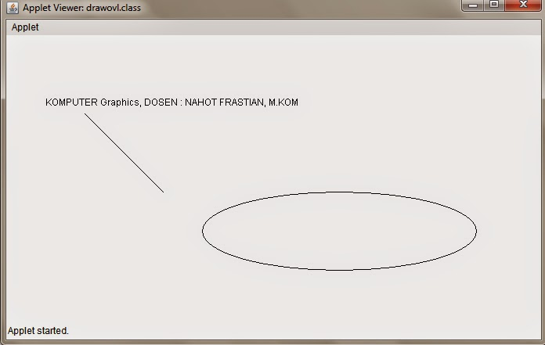

4.1Versi saya
import java.awt.Graphics;
public class heniDraw_Oval extends java.applet.Applet {
public void paint (Graphics g) {

g.drawString ("KOMPUTER Graphics, DOSEN : NAHOT FRASTIAN, M.KOM",30,180);
g.drawString ("Nama : Heni Meilani, NPM : 201143500292",70,200);
g.drawOval (90,50,180,100);
g.drawLine (50,100,310,100);
}
}
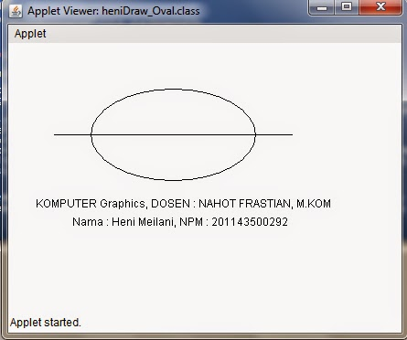

5.Komputer Grafik 6

import java.awt.Graphics;
import java.applet.Applet;
import java.awt.Color;

public class graphics2 extends java.applet.Applet {
public void paint (Graphics g) {
int xPts[] = {95,25,50,30,15,5};
int yPts[] = {10,35,20,65,40,10};

g.drawString ("KOMPUTER Graphics, DOSEN : NAHOT FRASTIAN, M.KOM",50,90);
g.setColor (Color.green);
g.drawRect (50,100,150,250);
g.drawRoundRect (50,150,150,250,6,12);
g.drawPolygon (xPts,yPts,xPts.length);
g.drawArc (50,100,150,275,95,115);
}
}
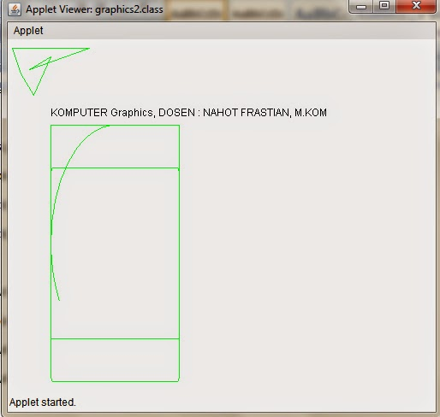

5.1Versi saya

import java.awt.Graphics;
import java.applet.Applet;
import java.awt.Color;
public class heniKG6 extends java.applet.Applet {
public void paint (Graphics g) {
int xPts[] = {220,115,160,205,100};
int yPts[] = {80,145,40,145,80};
g.drawString ("KOMPUTER Graphics, DOSEN : NAHOT FRASTIAN, M.KOM",30,240);
g.drawString ("Nama Mahasiswa : Heni Meilani",30,260);
g.drawString ("NPM : 201143500292",30,280);
g.setColor (Color.green);
g.drawRect (30,20,250,200);
g.drawRoundRect (50,25,210,150,12,6);
g.drawPolygon (xPts,yPts,xPts.length);
g.drawArc (70,60,170,100,10,-200);
}
}
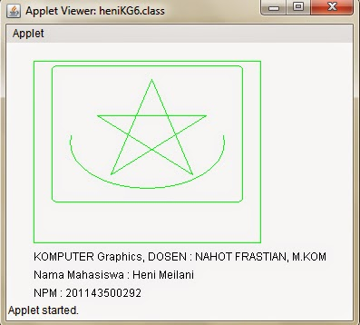

6.Komputer Grafik 7

import java.awt.Graphics;
import java.applet.Applet;
import java.awt.Color;

public class kg7 extends java.applet.Applet {
public void paint (Graphics g) {
int xPts[] = {95,25,50,30,15,5};
int yPts[] = {10,35,20,65,40,10};
g.drawString ("KOMPUTER Graphics, DOSEN : NAHOT FRASTIAN, M.KOM",50,90);
g.setColor (Color.red);
g.drawRect (50,100,150,250);
g.drawRoundRect (50,150,150,250,6,12);
g.drawPolygon (xPts,yPts,xPts.length);
g.drawArc (50,100,150,275,95,115);
g.drawOval(150,100,250,55);
}
}
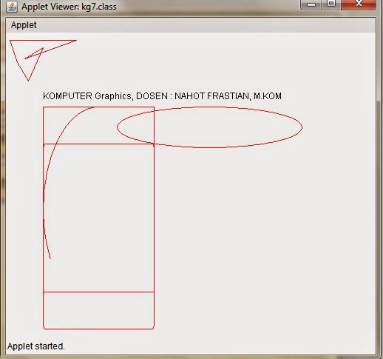

6.1Versi saya
import java.awt.Graphics;
import java.applet.Applet;
import java.awt.Color;
public class heniKG7 extends java.applet.Applet {
public void paint (Graphics g) {
int xPts[] = {220,115,160,205,100};
int yPts[] = {80,145,40,145,80};
g.drawString ("KOMPUTER Graphics, DOSEN : NAHOT FRASTIAN, M.KOM",30,240);
g.drawString ("Nama Mahasiswa : Heni Meilani",30,260);
g.drawString ("NPM : 201143500292",30,280);
g.setColor (Color.red);
g.drawRect (30,20,250,200);
g.drawRoundRect (50,25,210,150,12,6);
g.drawOval(300,20,70,200);
g.drawPolygon (xPts,yPts,xPts.length);
g.drawArc (70,60,170,100,10,-200);
}
}
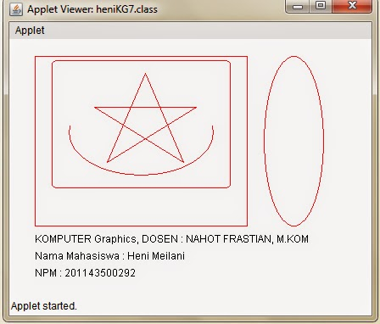

7.Komputer Grafik 8

import java.awt.Graphics;
import java.applet.Applet;
import java.awt.Color;

public class kg8 extends java.applet.Applet {
public void paint (Graphics g) {
int xPts[] = {95,25,50,30,15,5};
int yPts[] = {10,35,20,65,40,10};
g.drawString ("KOMPUTER Graphics, DOSEN : NAHOT FRASTIAN, M.KOM",50,90);
g.drawLine(5,100,150,250);
g.setColor (Color.blue);
g.drawRect (50,100,150,250);
g.drawRoundRect (50,150,150,250,6,12);
g.drawPolygon (xPts,yPts,xPts.length);
g.drawArc (50,100,150,275,95,115);
g.drawOval(150,100,250,55);
}
}
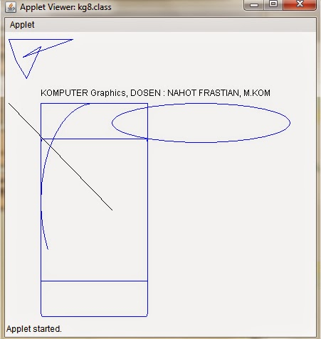

7.1Versi saya
import java.awt.Graphics;
import java.applet.Applet;
import java.awt.Color;
public class heniKG8 extends java.applet.Applet {
public void paint (Graphics g) {
int xPts[] = {220,115,160,205,100};
int yPts[] = {80,145,40,145,80};
g.drawString ("KOMPUTER Graphics, DOSEN : NAHOT FRASTIAN, M.KOM",30,240);
g.drawString ("Nama Mahasiswa : Heni Meilani",30,260);
g.drawString ("NPM : 201143500292",30,280);
g.drawLine(320,20,320,220);
g.setColor (Color.blue);
g.drawRect (30,20,250,200);
g.drawRoundRect (50,25,210,150,12,6);
g.drawOval(300,20,70,200);
g.drawPolygon (xPts,yPts,xPts.length);
g.drawArc (70,60,170,100,10,-200);
}
}
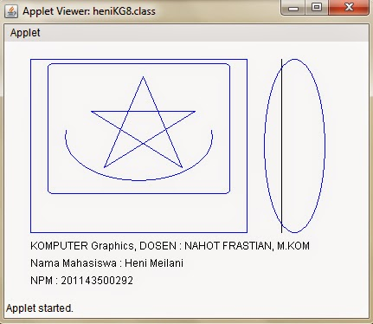

8.Komputer Grafik 9

import java.awt.Graphics;
import java.applet.Applet;
import java.awt.Color;
public class grafics1 extends java.applet.Applet {
public void paint (Graphics g) {
int xPts[] = {5,25,50,30,15,5};
int yPts[] = {10,35,20,65,40,10};
g.drawString ("KOMPUTER Graphics, DOSEN : NAHOT FRASTIAN, M.KOM",50,90);
g.setColor (Color.green);
g.drawRect (50,100,150,250);
g.drawRoundRect (50,150,150,250,6,12);
}
}
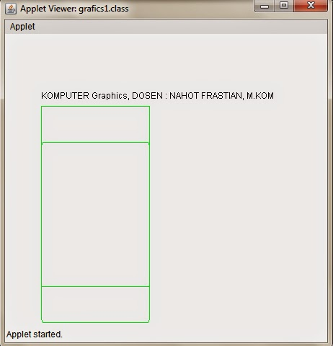

8.1Versi saya
import java.awt.Graphics;
import java.applet.Applet;
import java.awt.Color;

public class heniKG9 extends java.applet.Applet {
public void paint (Graphics g) {
int xPts[] = {220,115,160,205,100};
int yPts[] = {80,145,40,145,80};
g.drawString ("KOMPUTER Graphics, DOSEN : NAHOT FRASTIAN, M.KOM",30,240);
g.drawString ("Nama Mahasiswa : Heni Meilani",30,260);
g.drawString ("NPM : 201143500292",30,280);
g.setColor (Color.green);
g.drawRect (30,20,250,200);
g.drawRoundRect (50,25,210,150,12,6);
}
}
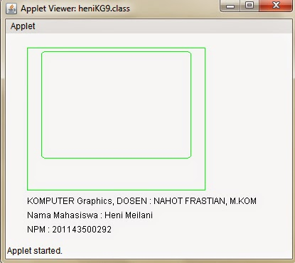

9.Komputer Grafik 10

import java.awt.Graphics;
import java.applet.Applet;
import java.awt.Color;
public class kg10 extends java.applet.Applet {
public void paint (Graphics g) {
int xPts[] = {95,25,50,30,15,5};
int yPts[] = {10,35,20,65,40,10};
g.drawString ("KOMPUTER Graphics, DOSEN : NAHOT FRASTIAN, M.KOM",50,90);
g.setColor (Color.green);
//g.drawRect (50,100,150,250);
//g.drawRoundRect (50,150,150,250,6,12);
g.drawPolygon (xPts,yPts,xPts.length);
g.drawArc (50,100,150,275,95,115);
}
}
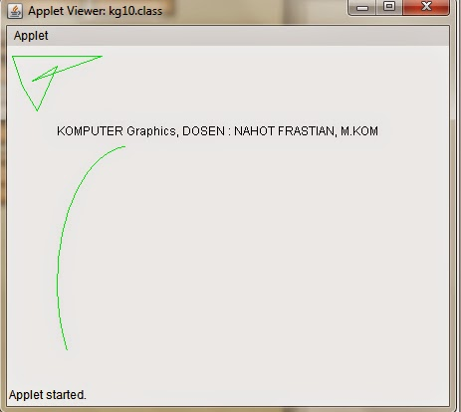

9.1Versi saya
import java.awt.Graphics;
import java.applet.Applet;
import java.awt.Color;
public class heniKG10 extends java.applet.Applet {
public void paint (Graphics g) {
int xPts[] = {220,115,160,205,100};
int yPts[] = {80,145,40,145,80};
g.drawString ("KOMPUTER Graphics, DOSEN : NAHOT FRASTIAN, M.KOM",30,240);
g.drawString ("Nama Mahasiswa : Heni Meilani",30,260);
g.drawString ("NPM : 201143500292",30,280);
g.setColor (Color.green);
//g.drawRect (30,20,250,200);
//g.drawRoundRect (50,25,210,150,12,6);
g.drawPolygon (xPts,yPts,xPts.length);
g.drawArc (70,60,170,100,10,-200);
}
}
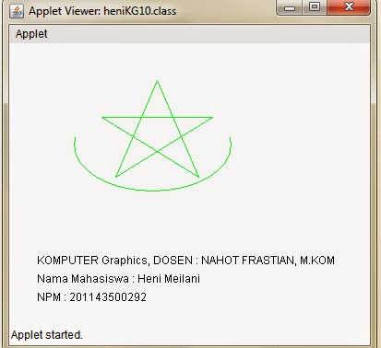

10.Komputer Grafik 11

import java.awt.Graphics;
public class SegiEmpat extends java.applet.Applet {
public void paint (Graphics g) {
g.drawRect (20,20,60,60);
g.fillRect (120,20,60,60);
}
}
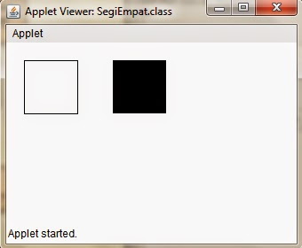

10.1Versi saya
import java.awt.Graphics;
import java.awt.Color;
public class heniKG11 extends java.applet.Applet {
public void paint (Graphics g) {
g.setColor(Color.red);
g.drawRect (20,20,60,60);
g.fillRect (120,20,60,60);
}
}
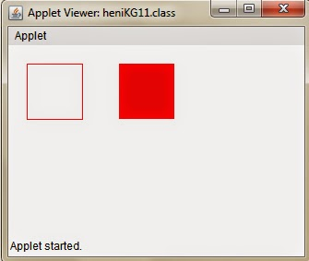

11.Komputer Grafik 12

import java.awt.Graphics;
public class SEGI extends java.applet.Applet {
public void paint (Graphics g) {
g.drawRect (50,100,150,250);
}
}
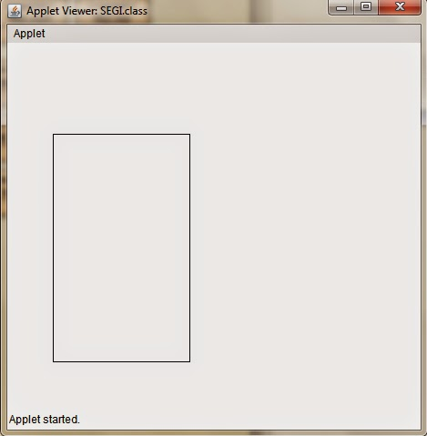

11.1Versi saya
import java.awt.Graphics;
import java.awt.Color;
public class heniKG12 extends java.applet.Applet {
public void paint (Graphics g) {
g.setColor(Color.blue);
g.drawRect (50,50,250,100);
}
}
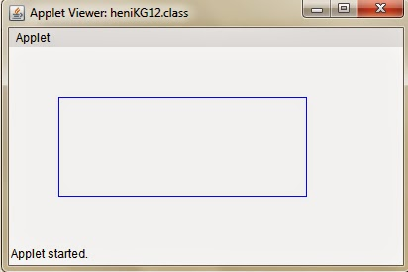

12.Komputer Grafik 13

import java.awt.Graphics;
public class SEGI4 extends java.applet.Applet {
public void paint (Graphics g) {
g.drawRoundRect (20,20,60,60,10,10);
}
}
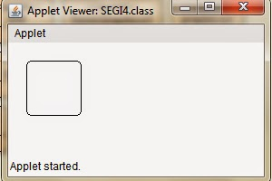

12.1Versi saya
import java.awt.Graphics;
import java.awt.Color;
public class heniKG13 extends java.applet.Applet {
public void paint (Graphics g) {
g.setColor(Color.red);
g.drawRoundRect (20,20,60,60,10,10);
}
}
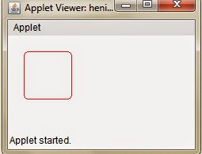

13.Komputer Grafik 14

import java.awt.Graphics;
public class segi4pat extends java.applet.Applet {
public void paint (Graphics g) {
g.drawRoundRect (20,20,60,60,10,10);
g.fillRoundRect (120,20,60,60,20,20);
}
}
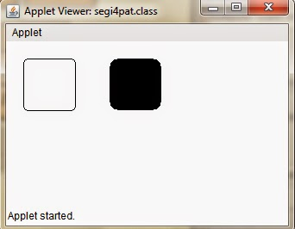

13.1Versi saya
import java.awt.Graphics;
import java.awt.Color;
public class heniKG14 extends java.applet.Applet {
public void paint (Graphics g) {
g.setColor(Color.green);
g.drawRoundRect (20,20,60,60,10,10);
g.fillRoundRect (120,20,60,60,20,20);
}
}
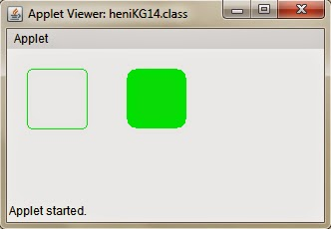

14.Komputer Grafik 15

import java.awt.Graphics;
public class Kotak3D extends java.applet.Applet {
public void paint (Graphics g) {
g.draw3DRect (20,20,60,60,true);
g.draw3DRect (120,20,60,60,false);
g.fill3DRect (122,22,58,57,true);
}
}
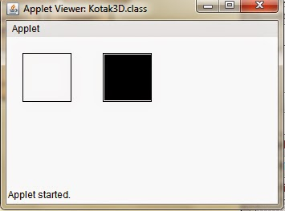

14.1Versi saya
import java.awt.Graphics;
import java.awt.Color;
public class heniKG15 extends java.applet.Applet {
public void paint (Graphics g) {
g.draw3DRect (20,20,60,60,true);
g.draw3DRect (120,20,60,60,false);
g.setColor(Color.orange);
g.fill3DRect (130,30,60,60,true);
}
}
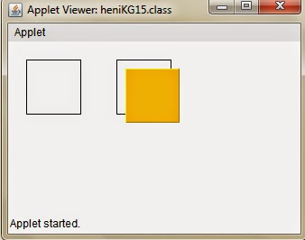

15.Komputer Grafik 16

import java.awt.Graphics;
public class MyPoly extends java.applet.Applet {
public void paint (Graphics g) {
int exes[] = {39,94,97,142,53,58,26};
int whys[] = {33,74,36,70,108,80,106};
int pts=exes.length;
g.drawPolygon (exes,whys,pts);
}
}
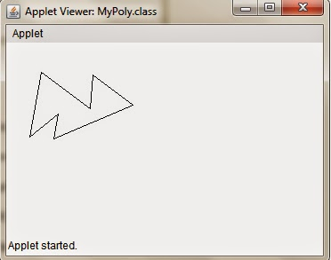

15.1Versi saya
import java.awt.Graphics;
public class heniKG16 extends java.applet.Applet {
public void paint (Graphics g) {
int xPts[] = {220,115,160,205,100};
int yPts[] = {70,135,30,135,70};
int zPts=xPts.length;
g.drawPolygon (xPts,yPts,zPts);
}
}
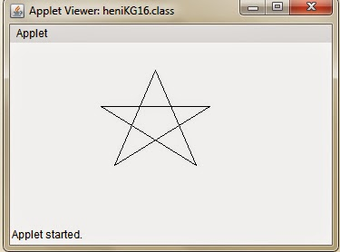

16.Komputer Grafik 16a

import java.awt.Graphics;
public class MyPoly1 extends java.applet.Applet {
public void paint (Graphics g) {
int exes[] = {39,94,97,142,53,58,26};
int whys[] = {33,74,36,70,108,80,106};
int pts=exes.length;
g.fillPolygon (exes,whys,pts);
}
}
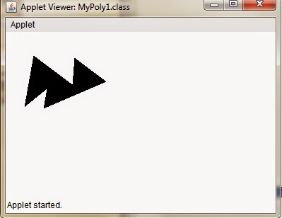

16.1Versi saya
import java.awt.Graphics;
public class heniKG16a extends java.applet.Applet {
public void paint (Graphics g) {
int xPts[] = {220,115,160,205,100};
int yPts[] = {70,135,30,135,70};
int zPts=xPts.length;
g.fillPolygon (xPts,yPts,zPts);
}
}
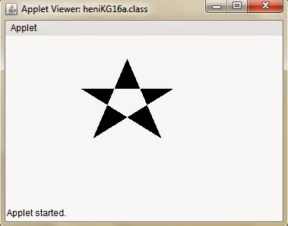

17.Komputer Grafik 17

import java.awt.Graphics;
public class setengahOval extends java.applet.Applet {
public void paint (Graphics g) {
g.drawArc(20,20,60,60,90,180);
g.fillArc(120,20,60,60,90,180);
}
}
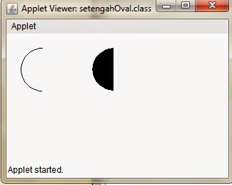

17.1Versi saya
import java.awt.Graphics;
public class heniKG17 extends java.applet.Applet {
public void paint (Graphics g) {
g.drawArc(20,20,80,80,180,180);
g.fillArc(120,20,80,80,180,180);
}
}
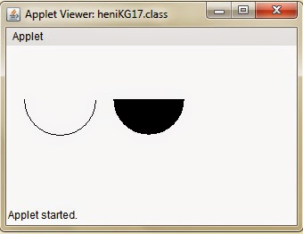

18.Komputer Grafik 18

import java.awt.Graphics;
public class MyOval extends java.applet.Applet {
public void paint (Graphics g) {
g.drawOval (20,20,60,60);
g.fillOval (120,20,100,60);
}
}
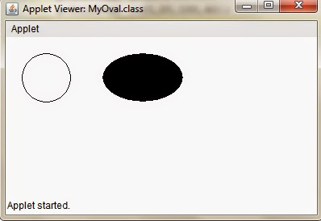

18.1Versi saya
import java.awt.Graphics;
public class heniKG18 extends java.applet.Applet {
public void paint (Graphics g) {
g.drawOval (20,20,80,80);
g.fillOval (60,30,130,70);
}
}
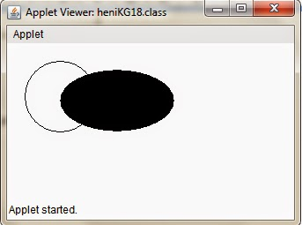

19.Komputer Grafik 19

import java.awt.Font;
import java.awt.Graphics;
public class ManyFonts extends java.applet.Applet {
public void paint (Graphics g) {
Font f=new Font("TimesRoman",Font.PLAIN,18);
Font fb=new Font("TimesRoman",Font.BOLD,18);
Font fi=new Font("TimesRoman",Font.ITALIC,18);
Font fbi=new Font("TimesRoman",Font.BOLD+Font.ITALIC,18);
g.setFont(f);
g.drawString("This is a Plain font",10,25);
g.setFont(fb);
g.drawString("This is a Bold font",10,50);
g.setFont(fi);
g.drawString("This is a Italic font",10,75);
g.setFont(fbi);
g.drawString("This is a Bold Italic font",10,100);
}
}
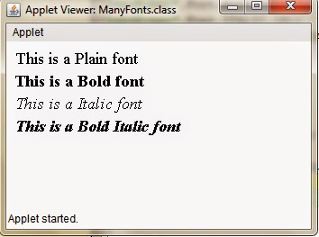

19.1Versi saya
import java.awt.Font;
import java.awt.Graphics;
import java.awt.Color;
public class heniKG19 extends java.applet.Applet {
public void paint (Graphics g) {
Font f=new Font("TimesRoman",Font.PLAIN,18);
Font fb=new Font("TimesRoman",Font.BOLD,18);
Font fi=new Font("TimesRoman",Font.ITALIC,18);
Font fbi=new Font("TimesRoman",Font.BOLD+Font.ITALIC,18);
g.setColor(Color.red);
g.setFont(f);
g.drawString("DOSEN : NAHOT FRASTIAN, M.Kom",10,25);
g.setFont(fb);
g.drawString("MATA KULIAH : KOMPUTER GRAFIK",10,50);
g.setFont(fi);
g.drawString("NAMA MAHASISWA : HENI MEILANI",10,75);
g.setFont(fbi);
g.drawString("NPM : 201143500292",10,100);
}
}
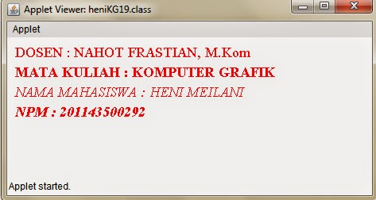

20.Komputer Grafik 20

import java.awt.Font;
import java.awt.Graphics;
public class ManyFonts1 extends java.applet.Applet {
public void paint (Graphics g) {
Font f=new Font("COMPUTER GRAPHICS",Font.PLAIN,18);
Font fb=new Font("DOSEN : NAHOT FRASTIAN, M.KOM",Font.BOLD,18);
Font fi=new Font("COMPUTER GRAPHICS",Font.ITALIC,18);
Font fbi=new Font("DOSEN : NAHOT FRASTIAN, M.KOM",Font.BOLD+Font.ITALIC,18);
g.setFont(f);
g.drawString("COMPUTER GRAPHICS",10,25);
g.setFont(fb);
g.drawString("DOSEN : NAHOT FRASTIAN, M.KOM",10,50);
g.setFont(fi);
g.drawString("COMPUTER GRAPHICS",10,75);
g.setFont(fbi);
g.drawString("DOSEN : NAHOT FRASTIAN, M.KOM",10,100);
}
}
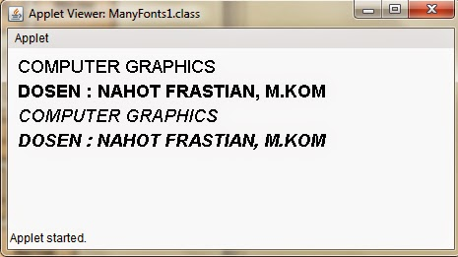

20.1Versi saya
import java.awt.Font;
import java.awt.Graphics;
import java.awt.Color;
public class heniKG20 extends java.applet.Applet {
public void paint (Graphics g) {
Font f=new Font("NAMA MAHASISWA : HENI MEILANI",Font.PLAIN,18);
Font fb=new Font("NPM : 201143500292",Font.BOLD,18);
Font fi=new Font("NAMA MAHASISWA : HENI MEILANI",Font.ITALIC,18);
Font fbi=new Font("NPM : 201143500292",Font.BOLD+Font.ITALIC,18);
g.setColor(Color.green);
g.setFont(f);
g.drawString("NAMA MAHASISWA : HENI MEILANI",10,25);
g.setFont(fb);
g.drawString("NPM : 201143500292",10,50);
g.setFont(fi);
g.drawString("NAMA MAHASISWA : HENI MEILANI",10,75);
g.setFont(fbi);
g.drawString("NPM : 201143500292",10,100);
}
}
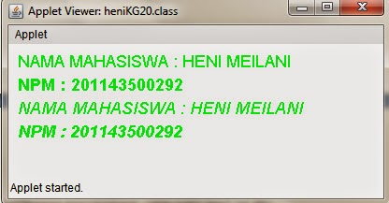

21.Komputer Grafik 21

import java.awt.*;
import java.applet.*;
import java.awt.geom.*;
public class myLine2D extends Applet {
public void paint(Graphics g){
//menetapkan pola garis (stroke)
float dashes[]={10.0f};
BasicStroke stroke1=new BasicStroke(5.0f,1,2,1.0f,dashes,0.0f);
//memilih objek grafik 2D
Graphics2D g2d=(Graphics2D) g;
//memberi warna hitam pada latar belakang
setBackground(Color.black);
//mengubah warna pena menjadi warna hijau
g2d.setPaint(Color.blue);
//membuat garis yang dikombinasikan dengan pola garis
g2d.setStroke(stroke1);
for(int i=0;i<=43;i++)
g2d.draw(new Line2D.Double(150,150,150+((int)150*Math.cos(i)),150+((int)150*Math.sin(i))));
}
}
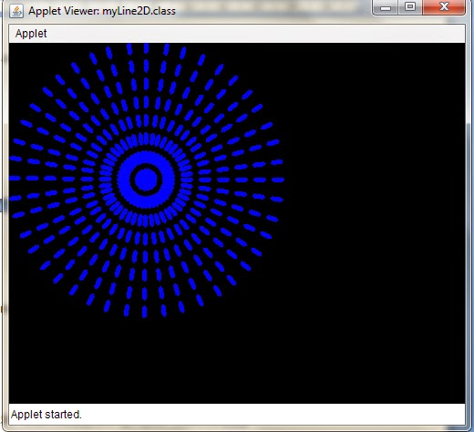

21.1Versi saya
import java.awt.*;
import java.applet.*;
import java.awt.geom.*;
public class heniKG21 extends Applet {
public void paint(Graphics g){
//menetapkan pola garis (stroke)
float dashes[]={10.0f};
BasicStroke stroke1=new BasicStroke(5.0f,1,2,1.0f,dashes,0.0f);
BasicStroke stroke2=new BasicStroke(5.0f,1,2,1.0f,dashes,0.0f);
//memilih objek grafik 2D
Graphics2D g2d=(Graphics2D) g;
//memberi warna hitam pada latar belakang
setBackground(Color.blue);
//mengubah warna pena menjadi warna hijau
g2d.setPaint(Color.orange);
//membuat garis yang dikombinasikan dengan pola garis
g2d.setStroke(stroke1);
for(int i=0;i<=43;i++)
g2d.draw(new Line2D.Double(150,150,150+((int)150*Math.cos(i)),150+((int)150*Math.sin(i))));
g2d.setStroke(stroke2);
for(int i=0;i<=43;i++)
g2d.draw(new Line2D.Double(450,150,450+((int)150*Math.cos(i)),150+((int)150*Math.sin(i))));
}
}
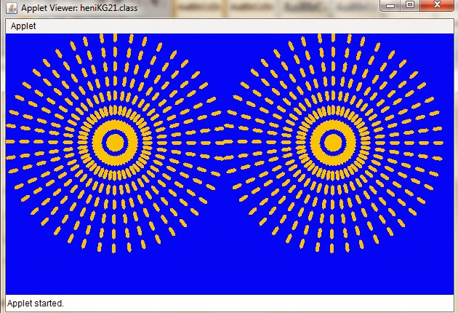

22.Komputer Grafik 22

import java.awt.*;
import java.applet.*;
import java.awt.geom.*;

public class kg22 extends Applet {
// definisi variabel
final static int maxCharHeight = 15;
final static int minFontSize = 6;
final static Color background = Color.white;
final static Color foreground = Color.black;
final static BasicStroke stroke = new BasicStroke(2.0f);
final static BasicStroke wideStroke = new BasicStroke(5.0f);
final static float dash[]={10.0f};
final static BasicStroke stroke02 = new BasicStroke(1.0f,0,1,10.f,dash,0.0f);
Dimension dim;
FontMetrics fontMetrics;
//fungsi inisialisasi

public void init() {
setBackground(background);
setForeground(foreground);
}

public void paint(Graphics g) {
Graphics2D g2d=(Graphics2D) g;
dim = getSize();
int width []=new int[6];
int height []=new int[3];
int i;
width[0]=0;
height[0]=0;
for(i=1;i<=5;i++)
width[i]=width[i-1]+dim.width/5;
for(i=1;i<=2;i++)
height[i]=height[i]+dim.height/2;
g2d.setPaint(Color.black);
g2d.fill(new Rectangle2D.Double(0,0,size().width,size().height));

//menggambar bentuk pertama berupa garis

g2d.setPaint(Color.yellow);
g2d.draw(new Line2D.Double(width[0],height[1]-20,width[1]-10,0));
g2d.drawString("Line2D",width[0]+20,height[1]-5);

//menggambar bentuk persegi dengan sudut tumpul
g2d.setStroke(stroke);
g2d.setPaint(Color.green);
g2d.fill(new RoundRectangle2D.Double(width[2],height[0],width[1]-10,height[1]-20,10,10));
g2d.drawString("RoundRectangle2D",width[2]+3,height[1]-5);
g2d.setPaint(Color.black);
g2d.fill(new RoundRectangle2D.Double(width[2]+5,height[0]+5,width[1]-20,height[1]-30,10,10));

//menggambar bentuk busur dengan isisnya
g2d.setStroke(stroke);
g2d.setPaint(Color.lightGray);
g2d.fill(new Arc2D.Double(width[2],height[1],width[1]-10,height[2]-20,150,270,2));
g2d.drawString("FilledArc2D",width[2]+20,(2*height[1])-5);

//menggambar bentuk busur
g2d.setStroke(wideStroke);
g2d.setPaint(Color.yellow);
g2d.draw(new Arc2D.Double(width[3],height[0]+5,width[1]-10,height[1]-20,60,180,0));
g2d.drawString("Arc2D",width[3]+20,height[1]-5);

//menggambar bentuk busur dengan isisnya
g2d.setStroke(stroke);
g2d.setPaint(Color.pink);
g2d.draw(new Arc2D.Double(width[3],height[1],width[1]-10,height[2]-20,0,225,1));
g2d.drawString("Arc2D",width[3]+20,(2*height[1])-5);

//menggambar bentuk ellipse dengan isinya diberikan warna gradien
g2d.setStroke(stroke);
g2d.setPaint(new GradientPaint(width[4],height[0],Color.white,size().width,size().height-50,Color.gray,true));
g2d.fill(new Ellipse2D.Double(width[4],height[0],width[1]-10,height[1]-20));
g2d.drawString("FilleEllipse2D",width[4]+10,height[1]-5);

//menggambar bentuk ellipse dengan isinya ditimpa dengan bentuk ellipse yang berupa bingkainya saja
g2d.setStroke(stroke);
g2d.setPaint(Color.magenta);
g2d.fill(new Ellipse2D.Double(width[4],height[1],width[1]-10,height[1]-20));
g2d.drawString("FilleEllipse2D",width[4]+10,(2*height[1])-5);
g2d.setPaint(Color.cyan);
g2d.draw(new Ellipse2D.Double(width[4],height[1],width[1]-10,height[2]-20));
}
}
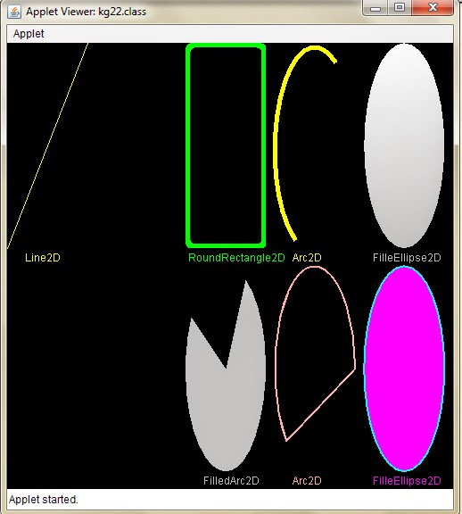

22.1Versi saya
import java.awt.*;
import java.applet.*;
import java.awt.geom.*;

public class heni22 extends Applet {
// definisi variabel
final static int maxCharHeight = 15;
final static int minFontSize = 6;
final static Color background = Color.white;
final static Color foreground = Color.blue;
final static BasicStroke stroke = new BasicStroke(2.0f);
final static BasicStroke wideStroke = new BasicStroke(5.0f);
final static float dash[]={10.0f};
final static BasicStroke stroke02 = new BasicStroke(1.0f,0,1,10.f,dash,0.0f);
Dimension dim;
FontMetrics fontMetrics;
//fungsi inisialisasi

public void init() {
setBackground(background);
setForeground(foreground);
}

public void paint(Graphics g) {
Graphics2D g2d=(Graphics2D) g;
dim = getSize();
int width []=new int[6];
int height []=new int[3];
int i;
width[0]=0;
height[0]=0;
for(i=1;i<=5;i++)
width[i]=width[i-1]+dim.width/5;
for(i=1;i<=2;i++)
height[i]=height[i]+dim.height/2;
g2d.setPaint(Color.blue);
g2d.fill(new Rectangle2D.Double(0,0,size().width,size().height));

//menggambar bentuk pertama berupa garis

g2d.setPaint(Color.red);
g2d.draw(new Line2D.Double(width[0],height[1]-20,width[1]-10,0));
g2d.drawString("Line2D",width[0]+20,height[1]-5);

//menggambar bentuk persegi dengan sudut tumpul
g2d.setStroke(stroke);
g2d.setPaint(Color.pink);
g2d.fill(new RoundRectangle2D.Double(width[2],height[0],width[1]-10,height[1]-20,10,10));
g2d.drawString("RoundRectangle2D",width[2]+3,height[1]-5);
g2d.setPaint(Color.blue);
g2d.fill(new RoundRectangle2D.Double(width[2]+5,height[0]+5,width[1]-20,height[1]-30,10,10));

//menggambar bentuk persegi dengan isinya
g2d.setStroke(stroke);
g2d.setPaint(Color.orange);
g2d.fill(new RoundRectangle2D.Double(width[1],height[0],width[1]-10,height[1]-20,0,0));
g2d.drawString("FilledRectangle2D",width[1]+3,height[1]-5);
g2d.setPaint(Color.orange);
g2d.fill(new RoundRectangle2D.Double(width[1]+5,height[0]+5,width[1]-20,height[1]-30,0,0));

//menggambar bentuk persegi
g2d.setStroke(stroke);
g2d.setPaint(Color.green);
g2d.fill(new RoundRectangle2D.Double(width[0],height[1],width[1]-10,height[1]-20,0,0));
g2d.drawString("Rectangle2D",width[0]+3,(2*height[1])-5);
g2d.setPaint(Color.blue);
g2d.fill(new RoundRectangle2D.Double(width[0]+5,height[1]+5,width[1]-20,height[1]-30,0,0));

//menggambar bentuk persegi2 dengan isinya
g2d.setStroke(stroke);
g2d.setPaint(Color.red);
g2d.fill(new RoundRectangle2D.Double(width[1],height[1],width[1]-10,height[1]-20,0,0));
g2d.drawString("FilledRectangle2D",width[1]+3,(2*height[1])-5);
g2d.setPaint(Color.red);
g2d.fill(new RoundRectangle2D.Double(width[1]+5,height[1]+5,width[1]-20,height[1]-30,0,0));

//menggambar bentuk busur dengan isisnya
g2d.setStroke(stroke);
g2d.setPaint(Color.cyan);
g2d.fill(new Arc2D.Double(width[2],height[1],width[1]-10,height[2]-20,150,270,2));
g2d.drawString("FilledArc2D",width[2]+20,(2*height[1])-5);

//menggambar bentuk busur
g2d.setStroke(wideStroke);
g2d.setPaint(Color.yellow);
g2d.draw(new Arc2D.Double(width[3],height[0]+5,width[1]-10,height[1]-20,60,180,0));
g2d.drawString("Arc2D",width[3]+20,height[1]-5);

//menggambar bentuk busur dengan isisnya
g2d.setStroke(stroke);
g2d.setPaint(Color.pink);
g2d.draw(new Arc2D.Double(width[3],height[1],width[1]-10,height[2]-20,0,225,1));
g2d.drawString("Arc2D",width[3]+20,(2*height[1])-5);

//menggambar bentuk ellipse dengan isinya diberikan warna gradien
g2d.setStroke(stroke);
g2d.setPaint(new GradientPaint(width[4],height[0],Color.white,size().width,size().height-50,Color.magenta,true));
g2d.fill(new Ellipse2D.Double(width[4],height[0],width[1]-10,height[1]-20));
g2d.drawString("FilledEllipse2D",width[4]+10,height[1]-5);

//menggambar bentuk ellipse dengan isinya ditimpa dengan bentuk ellipse yang berupa bingkainya saja
g2d.setStroke(stroke);
g2d.setPaint(Color.green);
g2d.fill(new Ellipse2D.Double(width[4],height[1],width[1]-10,height[1]-20));
g2d.drawString("FilledEllipse2D",width[4]+10,(2*height[1])-5);
g2d.setPaint(Color.red);
g2d.draw(new Ellipse2D.Double(width[4],height[1],width[1]-10,height[2]-20));
}
}

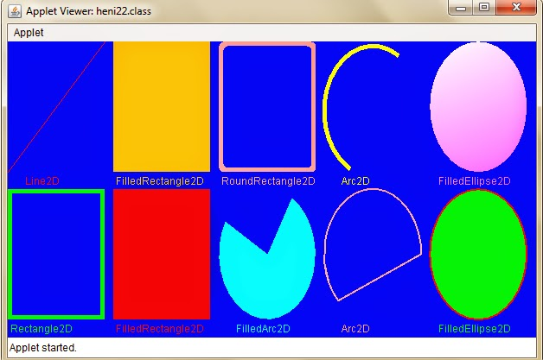

23.Komputer Grafik 23

import java.awt.*;
public class circle extends java.applet.Applet {
private int mouseX, mouseY;
private boolean mouseclicked=false;

public void init(){
setBackground(Color.magenta);
}
public boolean mouseDown(Event e,int x,int y){
mouseX=x; mouseY=y;
mouseclicked=true;
repaint();
return true;
}
public void paint(Graphics g){
g.setColor(Color.red);
if(mouseclicked){
g.fillOval((mouseX-5),(mouseY-5),10,10);
mouseclicked=false;
}
}
}
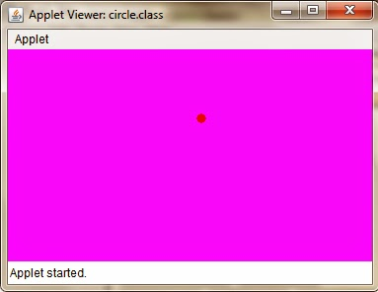

23.1Versi saya
import java.awt.*;
public class heniKG23 extends java.applet.Applet {
private int mouseX, mouseY;
private boolean mouseclicked=false;

public void init(){
setBackground(Color.yellow);
}
public boolean mouseDown(Event e,int x,int y){
mouseX=x; mouseY=y;
mouseclicked=true;
repaint();
return true;
}
public void paint(Graphics g){
g.setColor(Color.green);
if(mouseclicked){
g.fillOval((mouseX-5),(mouseY-5),10,10);
mouseclicked=false;
}
}
}
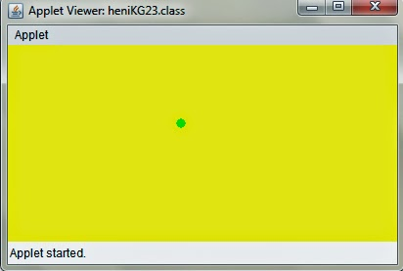

24.Komputer Grafik 24

import java.awt.*;
public class circle_right extends java.applet.Applet {
private int mouseX, mouseY;
private boolean mouseclicked=false;

public void init(){
setBackground(Color.magenta);
}
public boolean mouseDown(Event e,int x,int y){
mouseX=x; mouseY=y;
mouseclicked=true;
repaint();
return true;
}
public void paint(Graphics g){
g.setColor(Color.green);
if(mouseclicked){
g.fillOval((mouseX-5),(mouseY-5),10,10);
mouseclicked=false;
}
}
public void update(Graphics g){
paint (g);
g.drawString("KOMPUTER Graphics, DOSEN : NAHOT FRASTIAN, M.Kom",50,90);
}
}
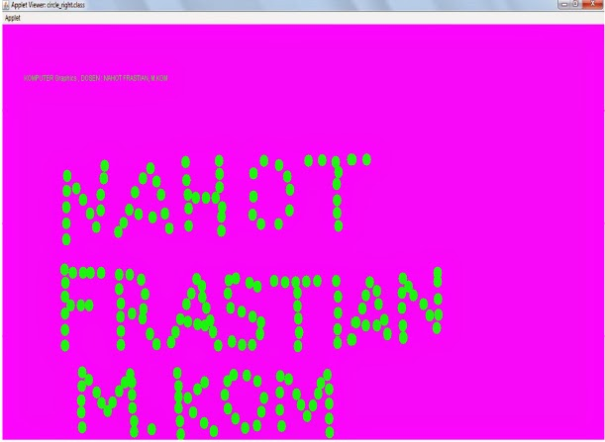

24.1Versi saya
import java.awt.*;
public class heniKG24 extends java.applet.Applet {
private int mouseX, mouseY;
private boolean mouseclicked=false;

public void init(){
setBackground(Color.green);
}
public boolean mouseDown(Event e,int x,int y){
mouseX=x; mouseY=y;
mouseclicked=true;
repaint();
return true;
}
public void paint(Graphics g){
g.setColor(Color.red);
if(mouseclicked){
g.fillOval((mouseX-5),(mouseY-5),10,10);
mouseclicked=false;
}
}
public void update(Graphics g){
paint (g);
g.drawString("HENI MEILANI 43500292",50,90);
}
}
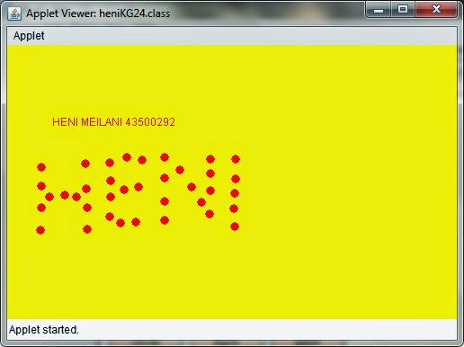

25.Komputer Grafik 25

import java.applet.*;
import java.awt.*;
import java.util.*;
import java.text.*;

public class kg25 extends Applet implements Runnable {

int width, height;
Thread t=null;
boolean threadSuspended;
int hours=0, minutes=0, seconds=0;
String timeString="";

public void init(){
width=getSize().width;
height=getSize().height;
setBackground(Color.red);
}

public void start(){
if(t==null){
t=new Thread(this);
t.setPriority(Thread.MIN_PRIORITY);
threadSuspended=false;
t.start();
}
else{
if(threadSuspended){
threadSuspended=false;
synchronized (this){
notify();
}
}
}
}

public void stop(){
threadSuspended = true;
}
public void run(){
try{
while(true){
Calendar cal=Calendar.getInstance();
hours=cal.get(Calendar.HOUR_OF_DAY);
if (hours>12) hours-=12;
minutes=cal.get(Calendar.MINUTE);
seconds=cal.get(Calendar.SECOND);

SimpleDateFormat formatter=new SimpleDateFormat("hh:mm:ss", Locale.getDefault());
Date date=cal.getTime();
timeString=formatter.format(date);

if(threadSuspended){
synchronized (this){
while (threadSuspended){
wait();
}
}
}
repaint();
Color[] c={Color.green, Color.red};
setBackground(c[seconds%2]);
t.sleep(1000);
}
}
catch(InterruptedException e){}}
void drawHand(double angle, int radius, Graphics g){
angle -=0.5*Math.PI;
int x=(int)(radius*Math.cos(angle));
int y=(int)(radius*Math.sin(angle));
g.drawLine(width/2, height/2, width/2+x, height/2+y);
}

void drawWedge(double angle, int radius, Graphics g){
angle -=0.5*Math.PI;
int x=(int)(radius*Math.cos(angle));
int y=(int)(radius*Math.sin(angle));
angle+=2*Math.PI/3;
int x2=(int)(5*Math.cos(angle));
int y2=(int)(5*Math.cos(angle));
angle+=2*Math.PI/3;
int x3=(int)(5*Math.cos(angle));
int y3=(int)(5*Math.cos(angle));
g.drawLine(width/2+x2, height/2+y2, width/2+x, height/2+y);
g.drawLine(width/2+x3, height/2+y3, width/2+x, height/2+y);
g.drawLine(width/2+x2, height/2+y2, width/2+x3, height/2+y3);
}

public void paint(Graphics g){
g.setColor(Color.black);
drawWedge(2*Math.PI*hours/12,width/5,g);
drawWedge(2*Math.PI*minutes/60,width/3,g);
drawWedge(2*Math.PI*seconds/60,width/2,g);
g.setColor(Color.black);
g.drawString(timeString,10, height-10);
g.drawString("KOMPUTER Graphics, DOSEN : NAHOT FRASTIAN, M.Kom",50,90);
}
}
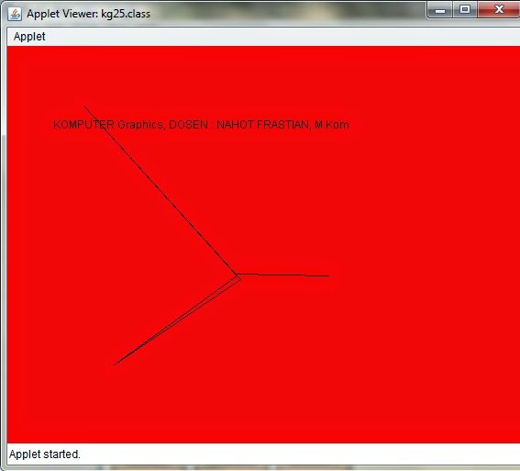

25.1Versi saya
import java.util.*;
import java.awt.*;
import java.applet.*;
import java.text.*;
import java.awt.Graphics;

public class jam1 extends Applet implements Runnable {
private volatile Thread timer; // The thread that displays clock
private int lastxs, lastys, lastxm,
lastym, lastxh, lastyh; // Dimensions used to draw hands
private SimpleDateFormat formatter; // Formats the date displayed
private String lastdate; // String to hold date displayed
private Font clockFaceFont; // Font for number display on clock
private Date currentDate; // Used to get date to display
private Color handColor; // Color of main hands and dial
private Color numberColor; // Color of second hand and numbers
private int xcenter = 80, ycenter = 55; // Center position
int width, height;
Thread t=null;
boolean threadSuspended;
int hours=0, minutes=0, seconds=0;
String timeString="";

public void init() {
width=getSize().width;
height=getSize().height;

int x,y;
lastxs = lastys = lastxm = lastym = lastxh = lastyh = 0;
formatter = new SimpleDateFormat ("EEE MMM dd yyyy hh:mm:ss",
Locale.getDefault());
currentDate = new Date();
lastdate = formatter.format(currentDate);
clockFaceFont = new Font("Serif", Font.PLAIN, 14);
handColor = Color.blue;
numberColor = Color.red;

try {
setBackground(new Color(Integer.parseInt(getParameter("bgcolor"),
16)));
} catch (NullPointerException e) {
} catch (NumberFormatException e) {
}

try {
handColor = new Color(Integer.parseInt(getParameter("fgcolor1"),
16));
} catch (NullPointerException e) {
} catch (NumberFormatException e) {
}

try {
numberColor = new Color(Integer.parseInt(getParameter("fgcolor2"),
16));
} catch (NullPointerException e) {
} catch (NumberFormatException e) {
}

resize(300,300); // Set clock window size
}

// Paint is the main part of the program
public void update(Graphics g) {
int xh, yh, xm, ym, xs, ys;
int s = 0, m = 10, h = 10;
String today;

currentDate = new Date();

formatter.applyPattern("s");

try {
s = Integer.parseInt(formatter.format(currentDate));
} catch (NumberFormatException n) {
s = 0;
}
formatter.applyPattern("m");

try {
m = Integer.parseInt(formatter.format(currentDate));
} catch (NumberFormatException n) {
m = 10;
}
formatter.applyPattern("h");

try {
h = Integer.parseInt(formatter.format(currentDate));
} catch (NumberFormatException n) {
h = 10;
}

// Set position of the ends of the hands
xs = (int) (Math.cos(s * Math.PI / 30 - Math.PI / 2) * 45 + xcenter);
ys = (int) (Math.sin(s * Math.PI / 30 - Math.PI / 2) * 45 + ycenter);
xm = (int) (Math.cos(m * Math.PI / 30 - Math.PI / 2) * 40 + xcenter);
ym = (int) (Math.sin(m * Math.PI / 30 - Math.PI / 2) * 40 + ycenter);
xh = (int) (Math.cos((h*30 + m / 2) * Math.PI / 180 - Math.PI / 2) * 30+ xcenter);
yh = (int) (Math.sin((h*30 + m / 2) * Math.PI / 180 - Math.PI / 2) * 30+ ycenter);

// Get the date to print at the bottom
formatter.applyPattern("EEE MMM dd yyyy HH:mm:ss");
today = formatter.format(currentDate);

g.setFont(clockFaceFont);
// Erase if necessary
g.setColor(getBackground());
if (xs != lastxs || ys != lastys) {
g.drawLine(xcenter, ycenter, lastxs, lastys);
g.drawString(lastdate, 5, 125);
}

if (xm != lastxm || ym != lastym) {
g.drawLine(xcenter, ycenter-1, lastxm, lastym);
g.drawLine(xcenter-1, ycenter, lastxm, lastym);
}

if (xh != lastxh || yh != lastyh) {
g.drawLine(xcenter, ycenter-1, lastxh, lastyh);
g.drawLine(xcenter-1, ycenter, lastxh, lastyh);
}

// Draw date and hands
g.setColor(numberColor);
g.drawString(today, 5, 125);
g.drawLine(xcenter, ycenter, xs, ys);
g.setColor(handColor);
g.drawLine(xcenter, ycenter-1, xm, ym);
g.drawLine(xcenter-1, ycenter, xm, ym);
g.drawLine(xcenter, ycenter-1, xh, yh);
g.drawLine(xcenter-1, ycenter, xh, yh);
lastxs = xs; lastys = ys;
lastxm = xm; lastym = ym;
lastxh = xh; lastyh = yh;
lastdate = today;
currentDate = null;
}

public void paint(Graphics g) {

g.setFont(clockFaceFont);
// Draw the circle and numbers

g.setColor(Color.red);
g.drawArc(xcenter-50, ycenter-50, 100, 100, 0, 360);
g.drawString("DOSEN : NAHOT FRASTIAN, M.Kom", 5,160);
g.drawString("MATA KULIAH : KOMPUTER GRAFIK", 5,180);
g.drawString("NAMA : HENI MEILANI", 5,200);
g.drawString("NPM : 201143500292", 5,220);
g.setColor(numberColor);
g.drawString("9", xcenter-45, ycenter+3);
g.drawString("3", xcenter+40, ycenter+3);
g.drawString("12", xcenter-5, ycenter-37);
g.drawString("6", xcenter-3, ycenter+45);

// Draw date and hands
g.setColor(numberColor);
g.drawString(lastdate, 5, 125);
g.drawLine(xcenter, ycenter, lastxs, lastys);
g.setColor(handColor);
g.drawLine(xcenter, ycenter-1, lastxm, lastym);
g.drawLine(xcenter-1, ycenter, lastxm, lastym);
g.drawLine(xcenter, ycenter-1, lastxh, lastyh);
g.drawLine(xcenter-1, ycenter, lastxh, lastyh);
}

public void start() {
timer = new Thread(this);
timer.start();
}

public void stop() {
timer = null;
}

public void run() {
Thread me = Thread.currentThread();
while (timer == me) {
try {
Thread.currentThread().sleep(100);
} catch (InterruptedException e) {
}
repaint();

}
}

public String getAppletInfo() {
return "Title: A Clock \n"
+ "Author: Heni Meilani, 2014 \n"
+ "An analog clock.";
}

public String[][] getParameterInfo() {
String[][] info = {
{"bgcolor", "hexadecimal RGB number",
"The background color. Default is the color of your browser."},
{"fgcolor1", "hexadecimal RGB number",
"The color of the hands and dial. Default is blue."},
{"fgcolor2", "hexadecimal RGB number",
"The color of the second hand and numbers. Default is red."}
};
return info;
}
}
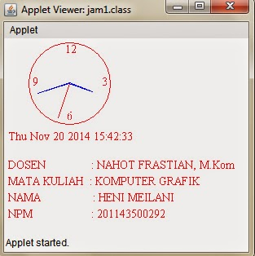

26.Komputer Grafik Bintang

import javax.swing.*;
import java.awt.Graphics;
import java.applet.Applet;
import java.awt.Color;

public class Bintang_Nahot_Frastian_M_Kom extends java.applet.Applet {
public void paint (Graphics Nahot) {
Nahot.setColor(Color.blue);
Nahot.drawString ("DOSEN : NAHOT FRASTIAN, M.Kom",60,40);
Nahot.drawString ("MATA KULIAH : KOMPUTER GRAFIK",60,60);
Nahot.drawString ("TEKNIK INFORMATIKA UNIVERSITAS INDRAPRASTA PGRI",60,80);

int xvalues[] = {180,40,270,40,180};
int yvalues[] = {100,310,225,150,350};
Nahot.setColor(Color.red);
Nahot.drawPolygon (xvalues,yvalues,xvalues.length);
int xvalues2[] = {380,240,470,240,380};
int yvalues2[] = {250,460,375,300,500};
Nahot.setColor(Color.green);
Nahot.fillPolygon (xvalues2,yvalues2,xvalues2.length);

}
}
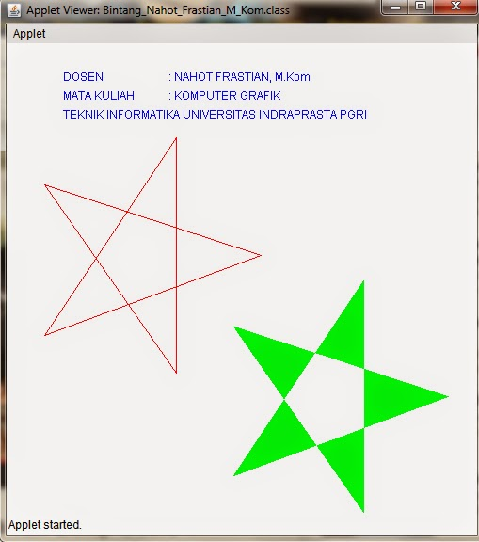

26.1.Versi Saya
import java.awt.Graphics;
import java.applet.Applet;
import java.awt.Color;

public class heniKG26 extends java.applet.Applet {
public void paint (Graphics g) {
//source string nama + warna
g.drawString ("DOSEN : NAHOT FRASTIAN, M.Kom",20,180);
g.drawString ("MATA KULIAH : KOMPUTER GRAFIK",20,200);
g.drawString ("NAMA MAHASISWA : HENI MEILANI",20,220);
g.drawString ("NPM : 201143500292",20,240);
g.drawString ("KELAS : 7 X K",20,260);
g.drawString ("TEKNIK INFORMATIKA UNIVERSITAS INDRAPRASTA PGRI",20,300);
//source poligon + fillpoligon + warna
int xPts[] = {170,65,110,145,50};
int yPts[] = {70,135,30,135,70};
int aPts[] = {330,225,270,305,210};
int bPts[] = {70,135,30,135,70};
g.setColor (Color.red);
g.drawPolygon (xPts,yPts,xPts.length);
g.setColor(Color.green);
g.drawPolygon (aPts,bPts,aPts.length);
g.fillPolygon (aPts,bPts,aPts.length);

}
}
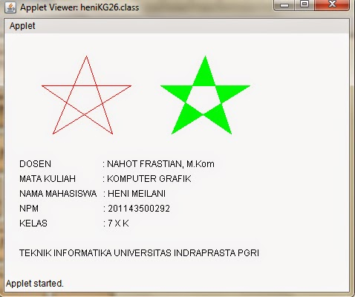

27.Komputer Grafik Bintang 1

import javax.swing.*;
import java.awt.Graphics;
import java.applet.Applet;
import java.awt.Color;

public class Bintang1 extends java.applet.Applet {
public void paint (Graphics g) {
g.setColor(Color.green);
g.drawString ("DOSEN : NAHOT FRASTIAN, M.Kom",60,50);
g.drawString ("MATA KULIAH : KOMPUTER GRAFIK",60,70);

int xvalues[] = {180,40,270,40,180};
int yvalues[] = {100,310,225,150,350};
g.setColor(Color.red);
g.drawPolygon (xvalues,yvalues,xvalues.length);
int xvalues2[] = {380,240,470,240,380};
int yvalues2[] = {250,460,375,300,500};
g.setColor(Color.blue);
g.fillPolygon (xvalues2,yvalues2,xvalues2.length);
}
}
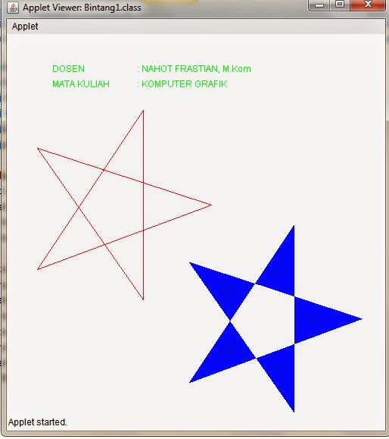

27.1.Versi Saya
import java.awt.Graphics;
import java.applet.Applet;
import java.awt.Color;

public class poli extends java.applet.Applet {
public void paint (Graphics g) {
//source string nama + warna
g.setColor (Color.blue);
g.drawString ("DOSEN : NAHOT FRASTIAN, M.Kom",20,180);
g.drawString ("MATA KULIAH : KOMPUTER GRAFIK",20,200);
g.drawString ("NAMA MAHASISWA : HENI MEILANI",20,220);
g.drawString ("NPM : 201143500292",20,240);
g.drawString ("KELAS : 7 X K",20,260);
g.drawString ("TEKNIK INFORMATIKA UNIVERSITAS INDRAPRASTA PGRI",20,300);
//source poligon + fillpoligon + warna
int xPts[] = {170,65,110,145,50};
int yPts[] = {70,135,30,135,70};
int aPts[] = {330,225,270,305,210};
int bPts[] = {70,135,30,135,70};
g.setColor (Color.red);
g.drawPolygon (xPts,yPts,xPts.length);
g.drawPolygon (aPts,bPts,aPts.length);
g.fillPolygon (aPts,bPts,aPts.length);
}
}

